**Additional Case Information**

1. Although the total project price to Wilmont must not exceed the overall project constraint of $750,000, the client now expects the actual price to be considerably less than what your CEO indicated it *could cost.* So, to meet your client’s budgetary expectations, your initial pricing should reflect your own reasonable, defensible effort and corresponding costs. As a reminder, the project schedule should begin January 5 and should meet the schedule constraints as specified in the case for completion. Note the resource limitations specified in the assignment instructions.

2. For the WBS for your budget estimate, use the one you developed in Assignment #2, along with any updates or revisions your team may have made. You must ensure that all deliverables from Assignment #1 (plus any updates) are included within the appropriate work packages in your WBS and that each includes adequate efforts for design, development, testing and implementation, as appropriate. You do not need to include a procurement management plan, staffing plan, or quality management plan as these are specifically excluded at this time. This assignment is designed for you to specify how you might deliver a detailed WBS and budget for this case problem to your boss, and it will be evaluated that way.

3. As stated above, it is up to you to make sure the appropriate level of project management, communication, testing and training tasks as needed are included to make the project successful. Use the information in the case along with your own ideas about how much effort is involved to ensure a quality implementation throughout the project, but also ensure you do not exceed the total project constraints.

4. Remember that this project will be tight in terms of time and cost, so do not include steps that are not necessary for successful project delivery.

5. The personnel involved from Wilmont do not have billing rates per hour because their cost is being separately budgeted by Wilmont. However, the effort for these Wilmont staff should be listed in your resource sheet, but with a $0.00 standard rate, and they should be aligned to the appropriate tasks that they will support for the project.

* + - George Cranston (GWC), Operations VP
    - James Connor (JFC), CIO
    - Mary Pearson (MJP), Project Lead, IT Systems Team
    - William Scott (WKS), Project Lead, Security Team
    - Julie Green (JRG), Pharmacy Manager Store #35864
    - Steve Haskell (SLH), Pharmacy Manager Store #32185
    - James O’Donnell (JLO), Pharmacy Manager Store #38734
    - Wilma Marcy (WPM), Pharmacy Manager Store #33001
    - Phillip Greenberg (PAG), Project Manager on the Business Operations side
    - Jonathan Perry (JSP), Retail Operations Assistant
    - Linda Thornton (LET), Online Customer Process Analyst
    - Gerald Peritoni (GEP), Testing Specialist
    - Elizabeth Walton (EMW), Senior Testing Specialist
    - Shirley Johnson (SPJ), Change Management Coordinator
    - Alan Swanson (AES), Attorney – Legal Department

6. Special Equipment Needed and other expenses:

* New Drone Procurement: Assume each new delivery drone will cost $18,034.00. DroneTech will supply four of these to Wilmont for the purpose of the prototype project. The cost of the drones should be incorporated into the budget of your project as non-labor expenses (material resources).
* Drone Maintenance/Repair Parts: You should allow $20,000 worth of spare drone parts and batteries to be on‐hand for this project and budget these expenses accordingly in the tasks where they will most likely be incurred.
* Include any other necessary expenses like travel, exceptional reporting costs, and other needed expenses.

7. DroneTech’ s Staff, hourly billing rates (these rates are inclusive of fringe benefits, overhead, and profit) and official abbreviated names (initials):

* Jordan Kempler (JXK), CEO and Founder ($250/hr billing rate)

* You as Project Manager overall for DroneTech (Add your own initials) ($145/hr billing rate)
* Stephanie Williams (SMW), Senior Business Analyst ($100/hr)
* Gerald Hasper (GPH), Flight Operations Manager ($78/hr)
* Eileen Seymour (ERS), Project Lead, IT Systems ($105/hr)

* Katie O’Ryan (KRO), Corporate Attorney – DroneTech ($300/hr)

* Rohan Shah (RXS), Programmer ($60/hr)
* Shravani Sinha (SXS), Senior Programmer ($75/hr)
* William Holt (WKH), Drone Systems Engineer ($65/hr)
* Ashish Nehra (AXN), Drone Systems Technician ($50/hr)

* Any member of your class team that are serving roles ($90/hr)

Wilmont’s/DroneTech Legal Contract Negotiations (160 hours)

Had 152 previously, 160 now

Specialized Customer Order/Information Interface (150 hours)

Already had the information in MSP

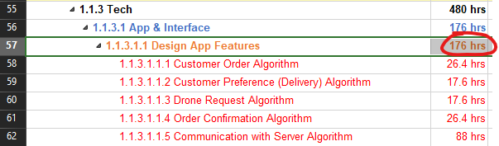

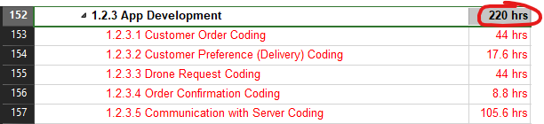

Custom Management Reporting Interface (135 hours)

Customization of Flight/Delivery Processing (75 hours)

Clarified tasks to reflect the algorithm as well

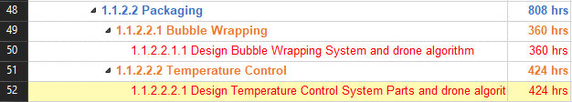

Custom Drone Construction (40 hours each for 4 drones – 160 hours total)

Increased timeline for customization

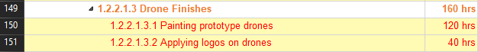

Custom Temperature/Shock Protection Product Carrier (160 hours)

Already reached constraint

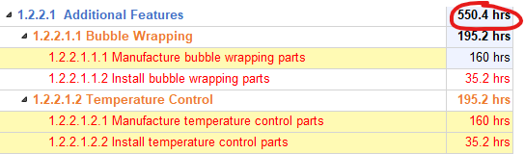

Flight path engineering (120 hours)

This includes the flight path engineering – tweaking code as necessary.

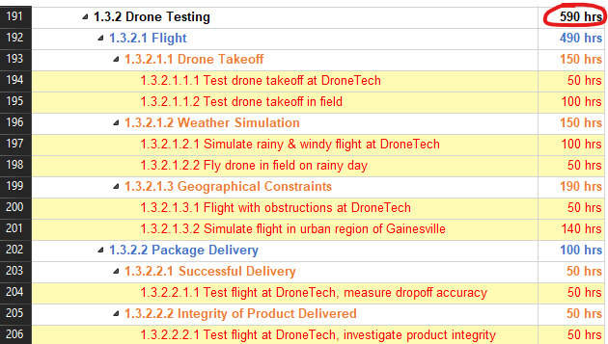

Pharmacy Manager Drone Delivery Operations Procedures (80 hours)

Already accounted for this

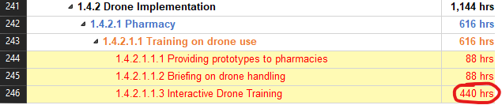

Drone Maintenance/Repair Procedures and Parts (80 hours)

Already accounted for this

